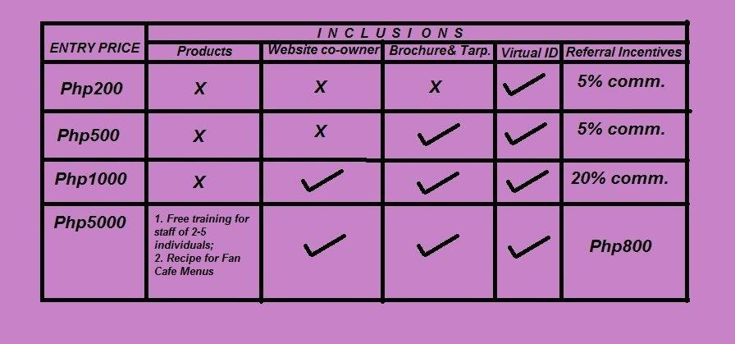
WELCOME BTS-ARMY FRANCHISEE PARTNER!

You are invited to become our FULLTIME BTS-ARMY FAN CAFE PARTNER!

While BTS is trending and famous, this Fan Cafe is a fast-moving and strategic way to earn at home.

REGISTER NOW!!!

Franchising Business Mode Entry

Select preferred payment for Franchising Business Mode Entry (refer to above inclusions and entry price) and send cash to:

Gcash: 09193846335 Name: Gracie O. Ching

PayPal: kyondrenyoongi@gmail.com

ATM bank account:

Name: Gracie O. Ching

Bank name: Metropolitan Bank and Trust Company ( Metrobank)

Swift code:MBTCPHMMXXX

Routing number:010269996

Account number: 612-3-612-11758-7
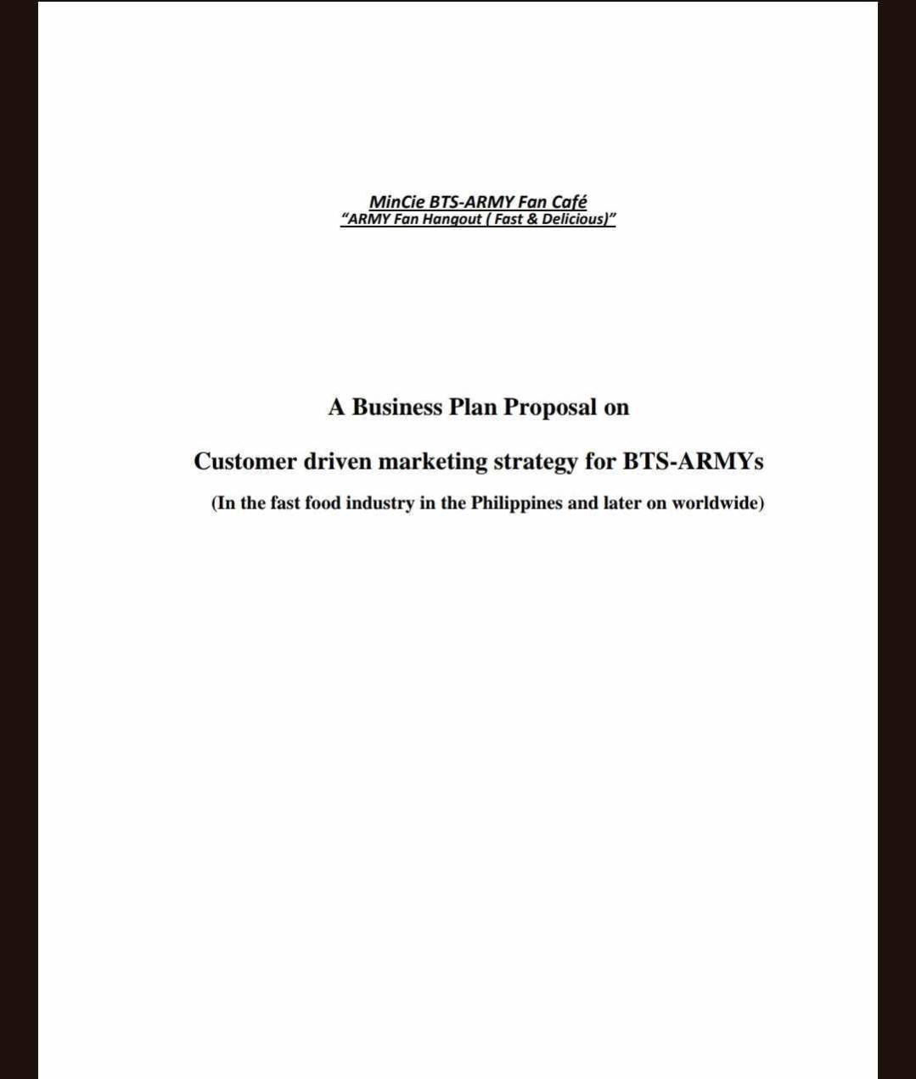
Request for training via Google meet for the franchisee business format and it will be sent thru email. Registration link will be sent to you via email upon request.

For more request and further inquiries, send email to GracieChing@protonmail.ph or text us at 09165862868 for globe; 09193846335 for smart users.

Print the Proposed BTS-ARMY Fan Café business format for your sample on the following pages.
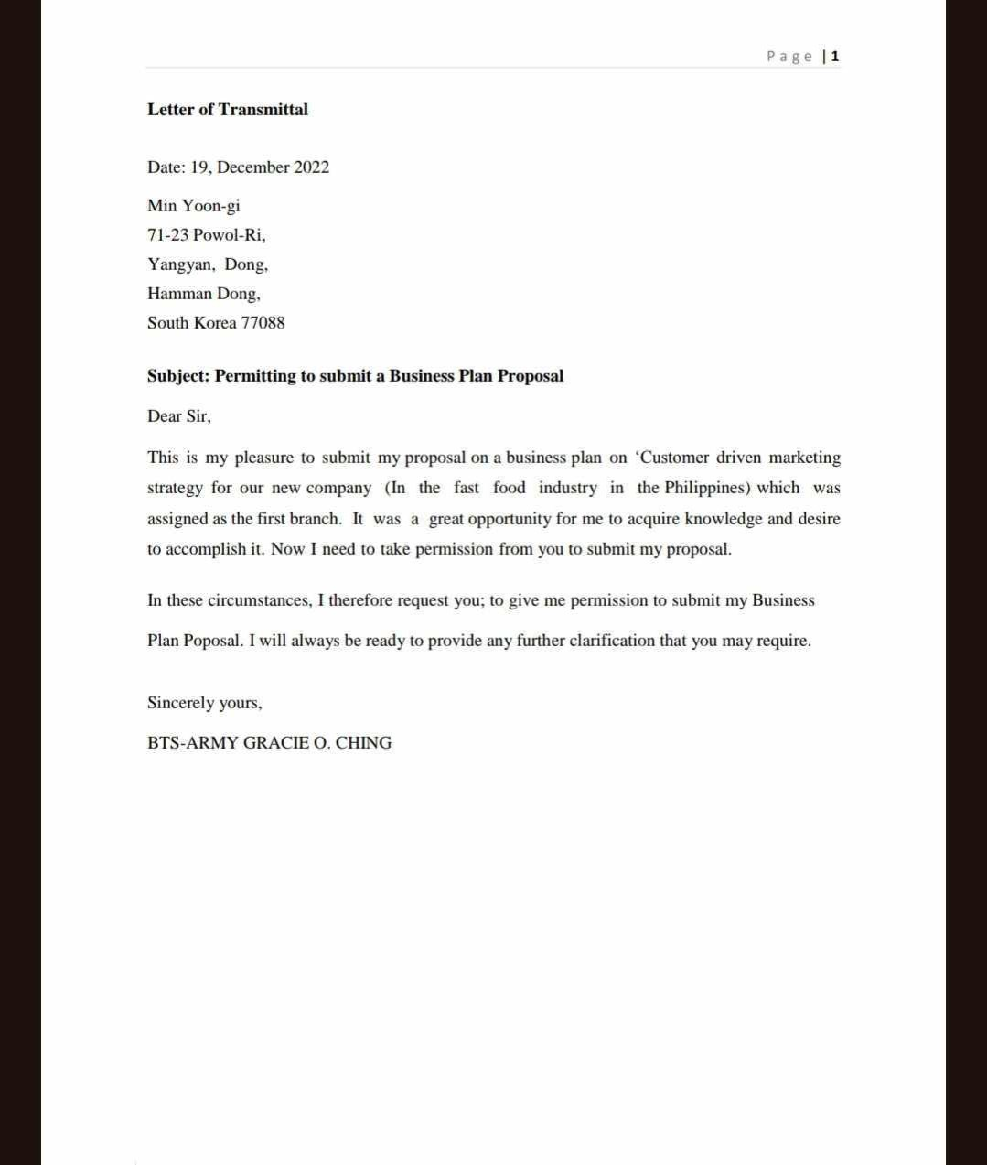
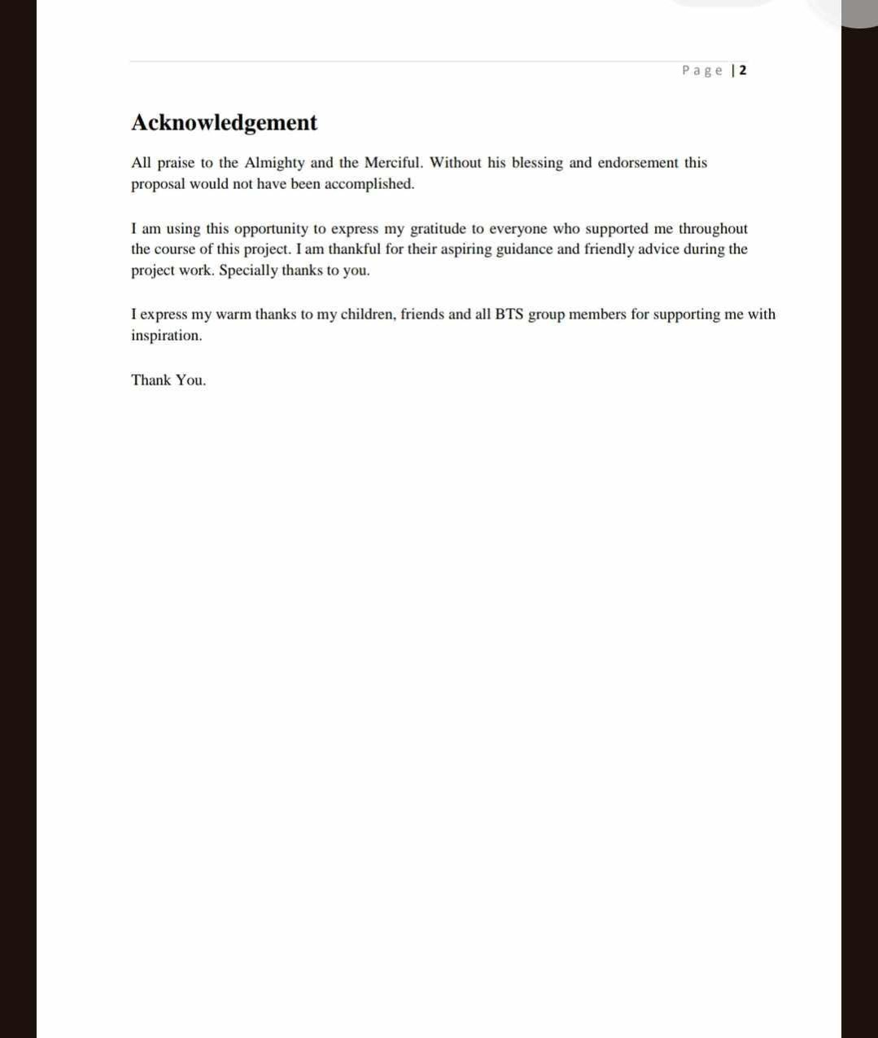
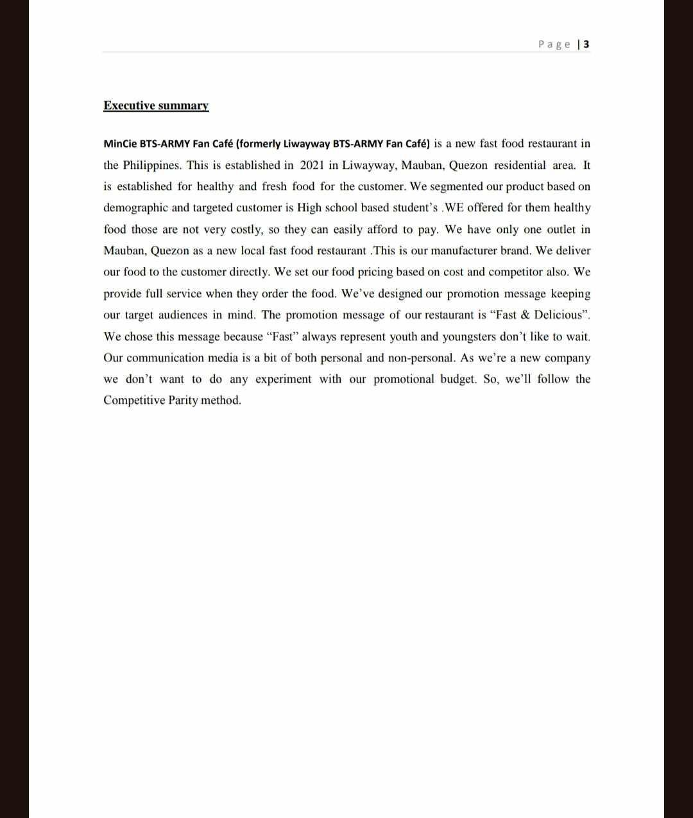
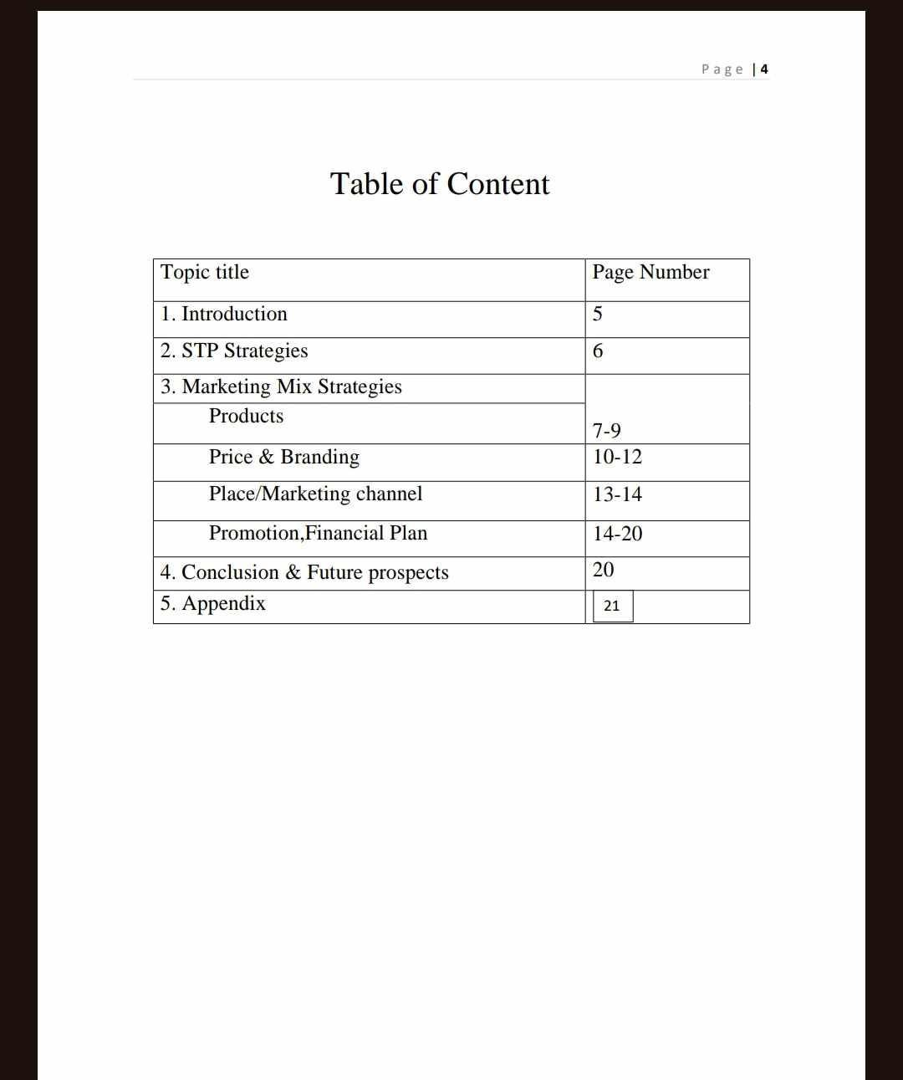
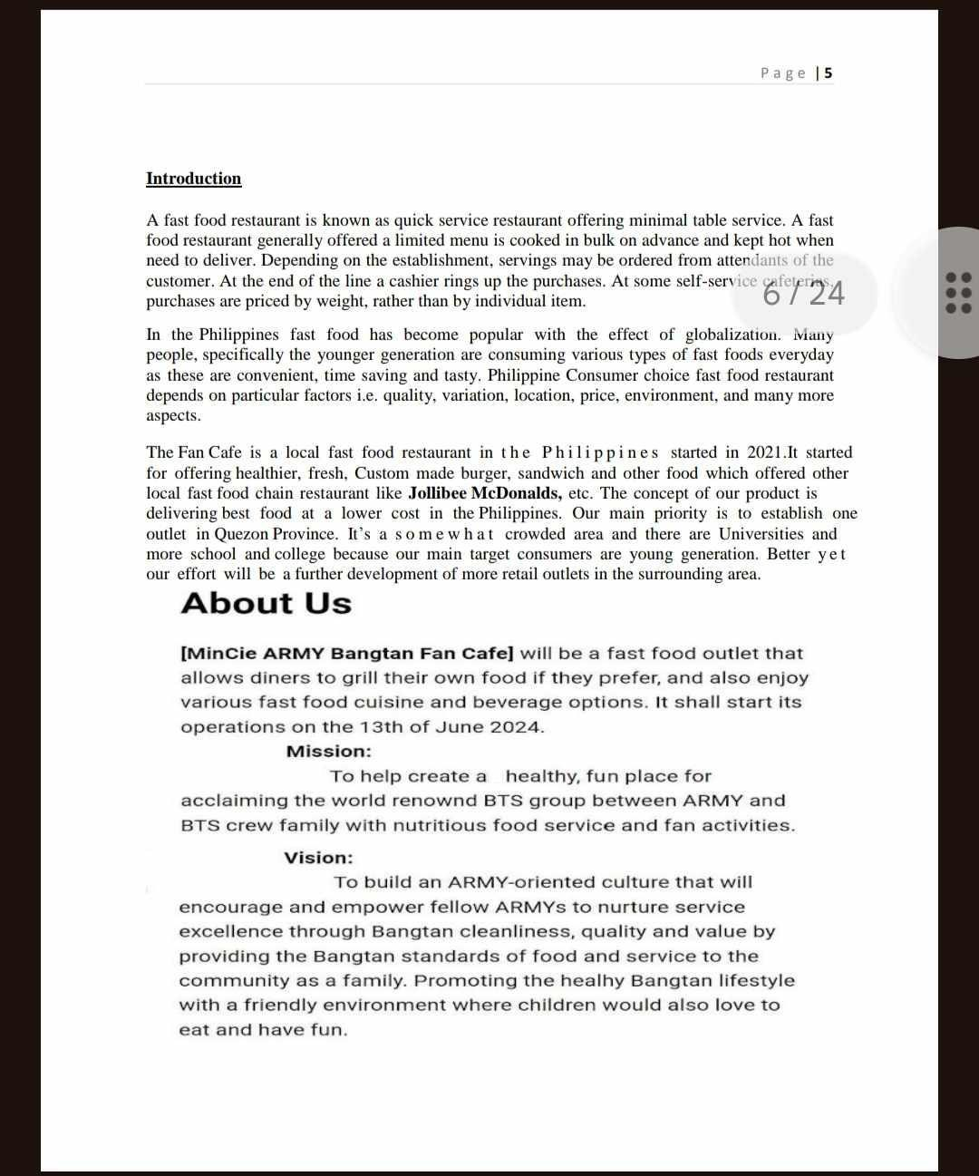
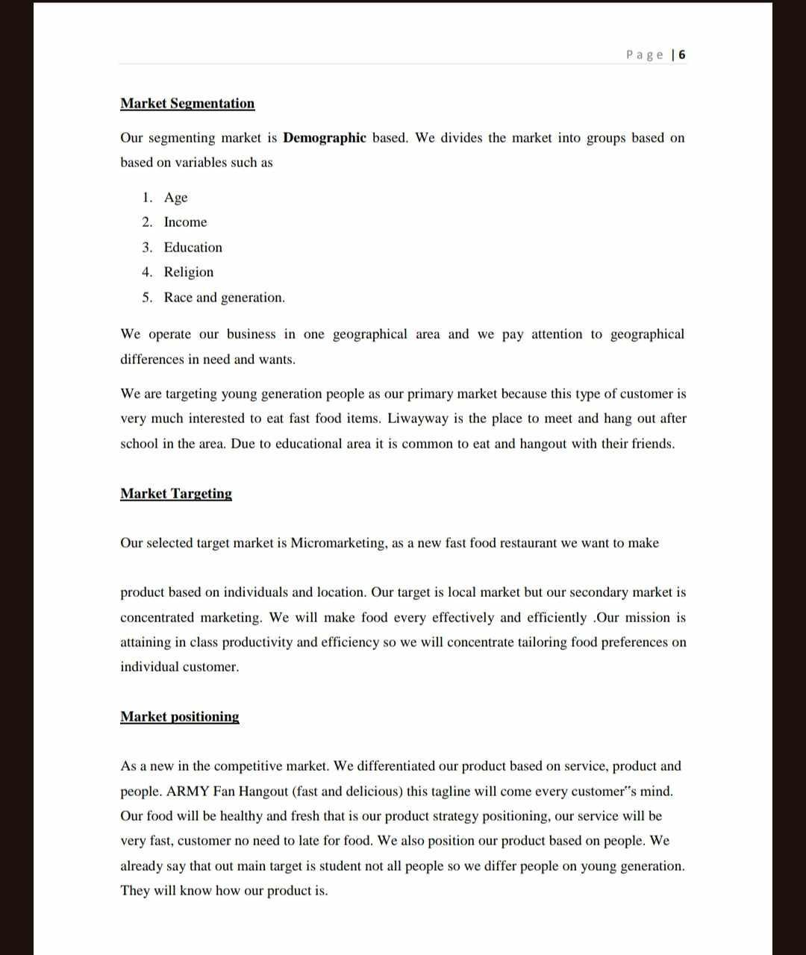
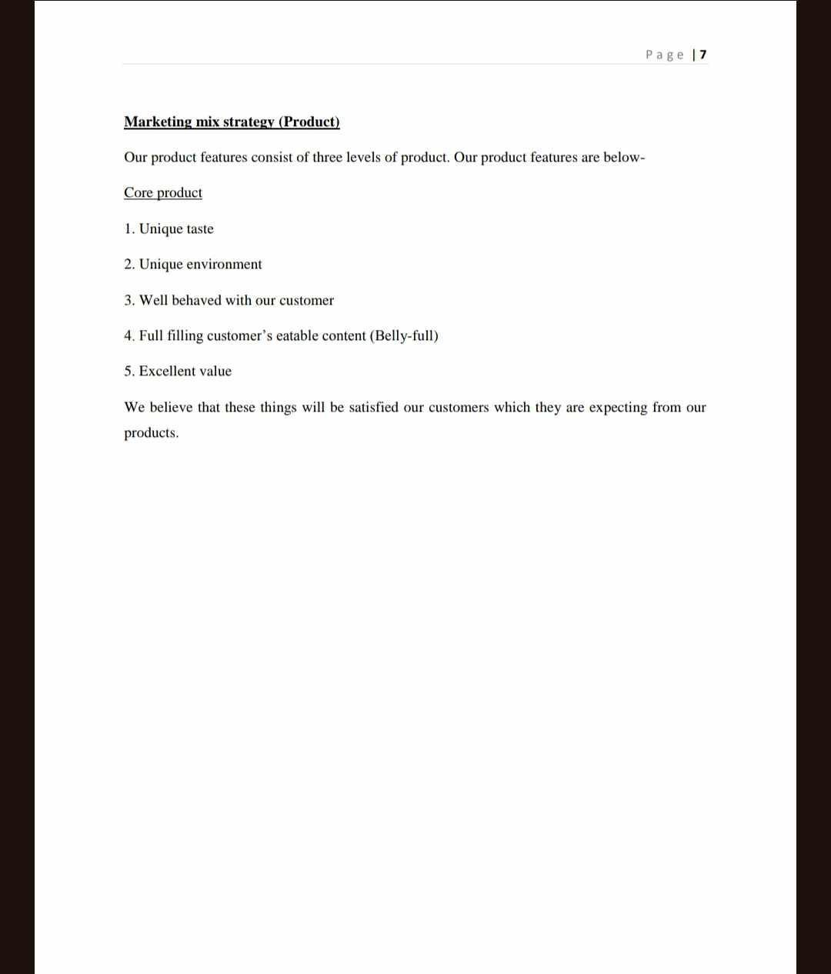
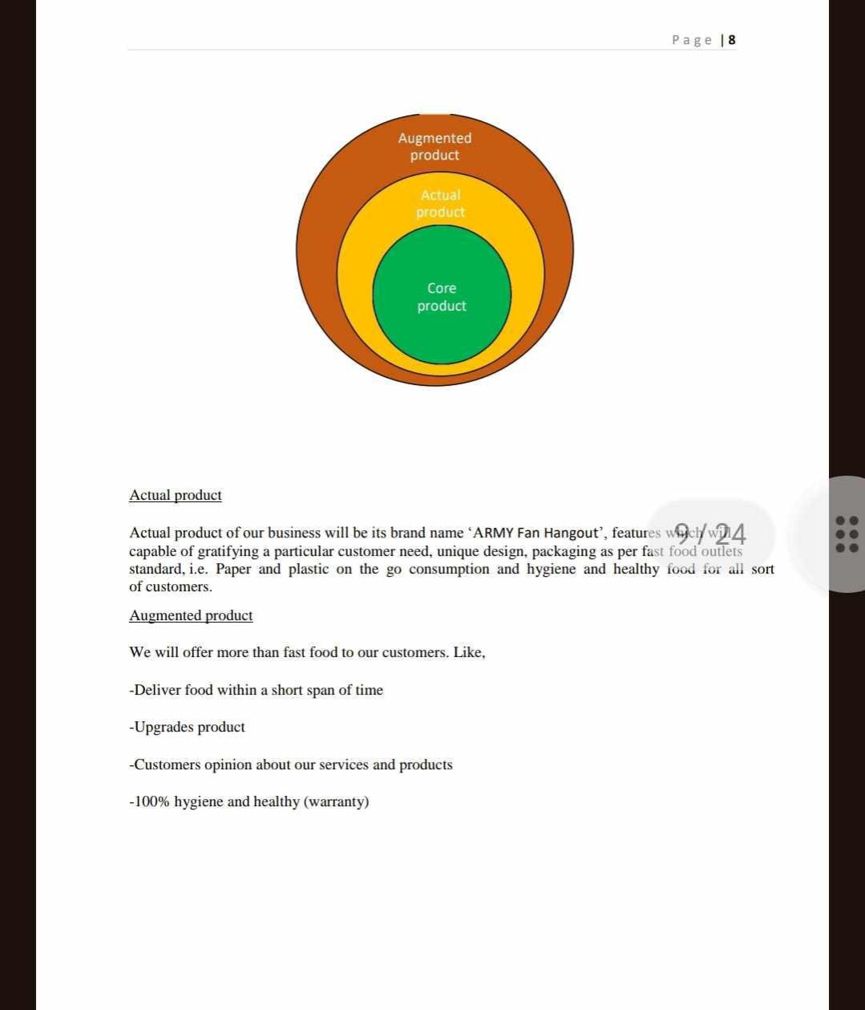
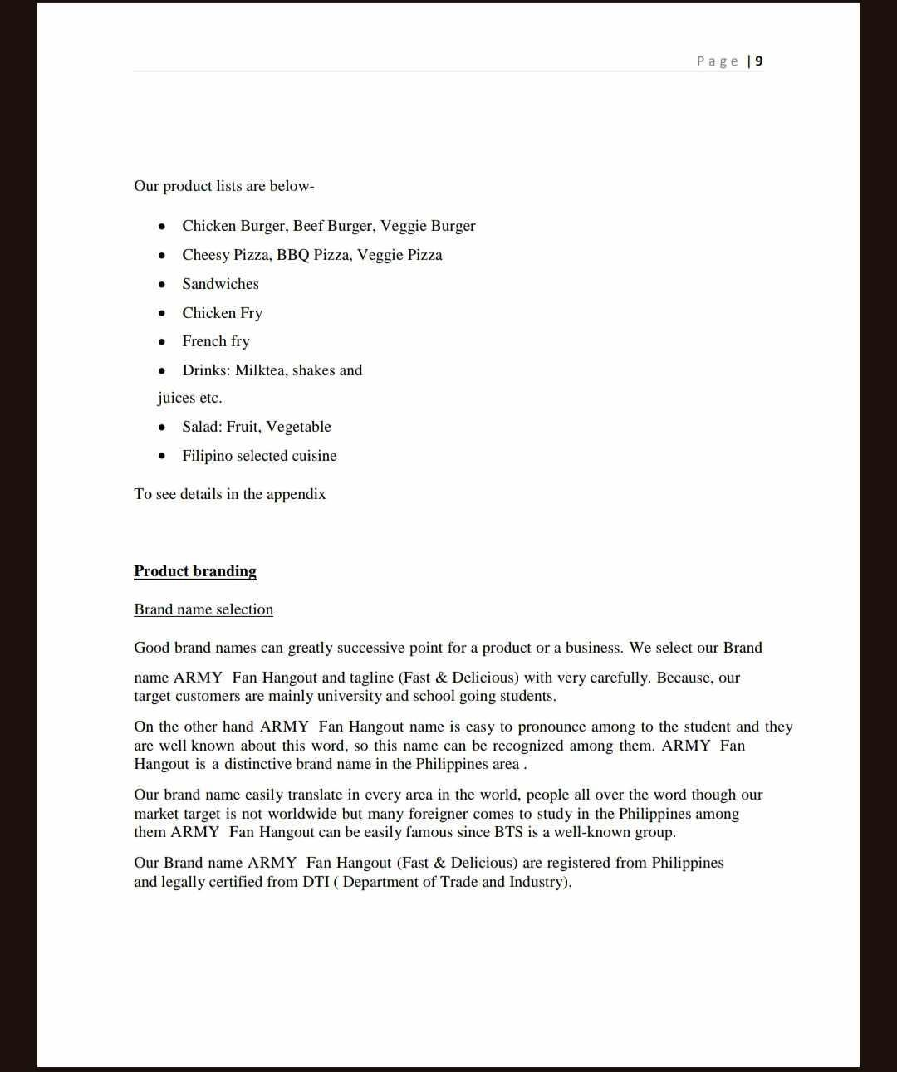
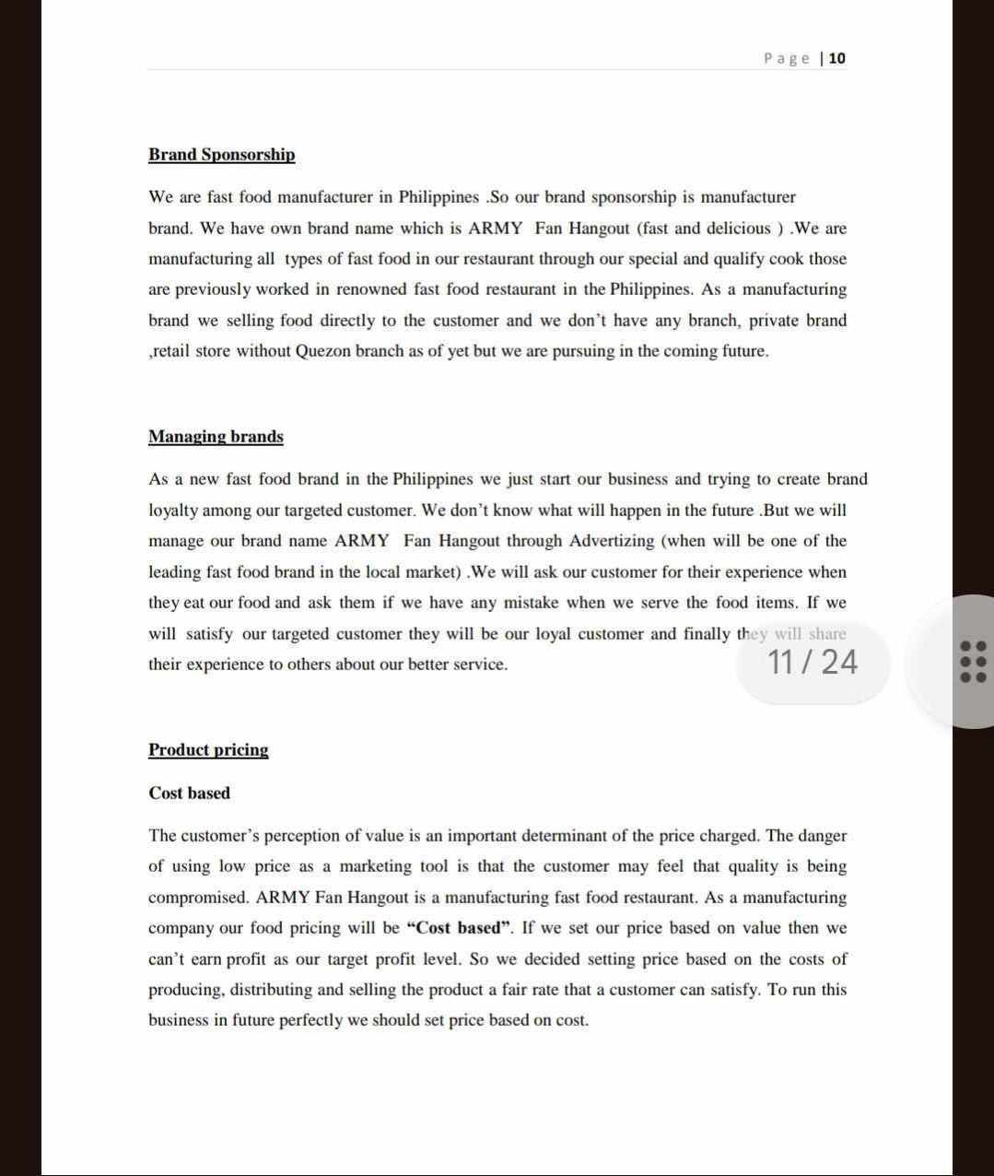
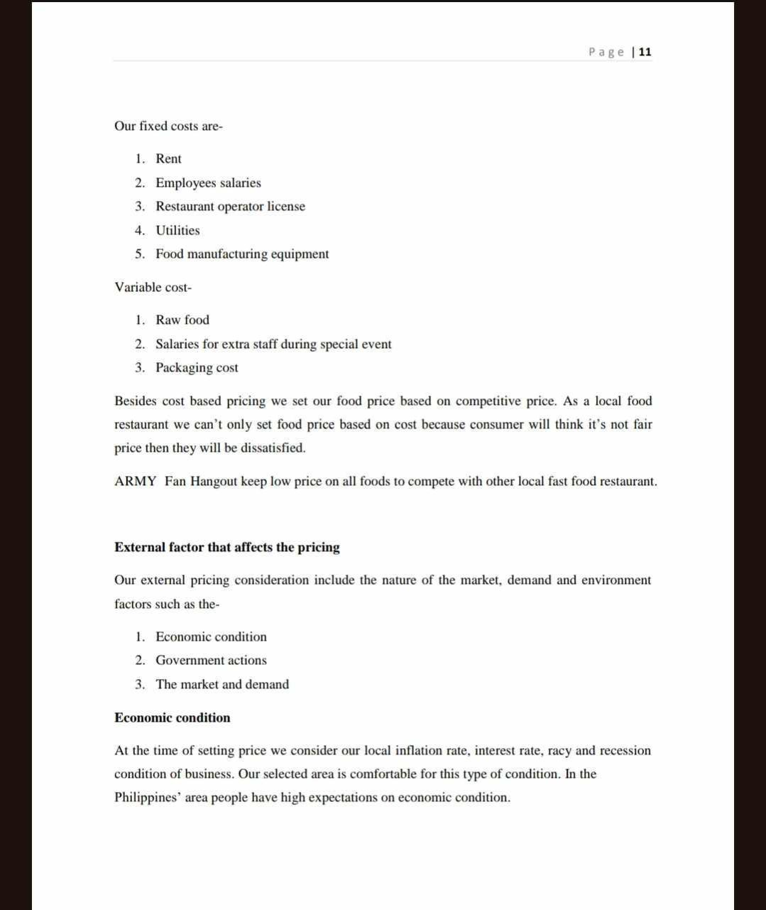
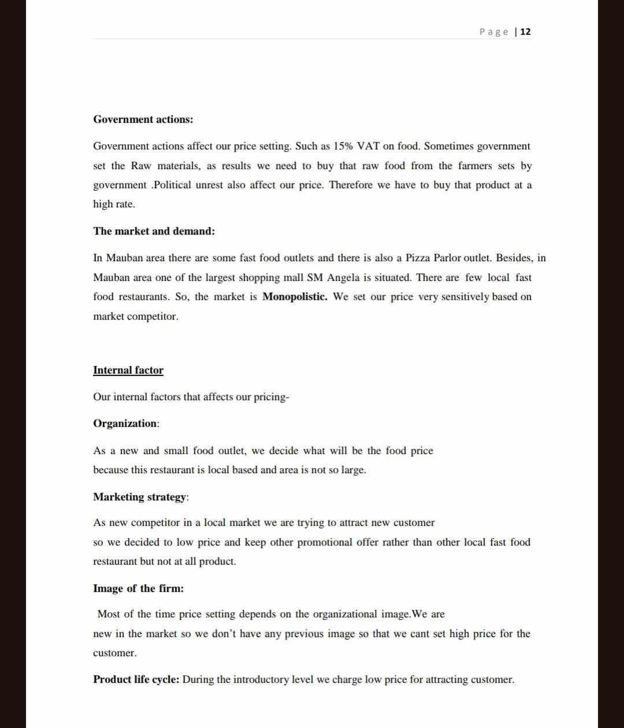
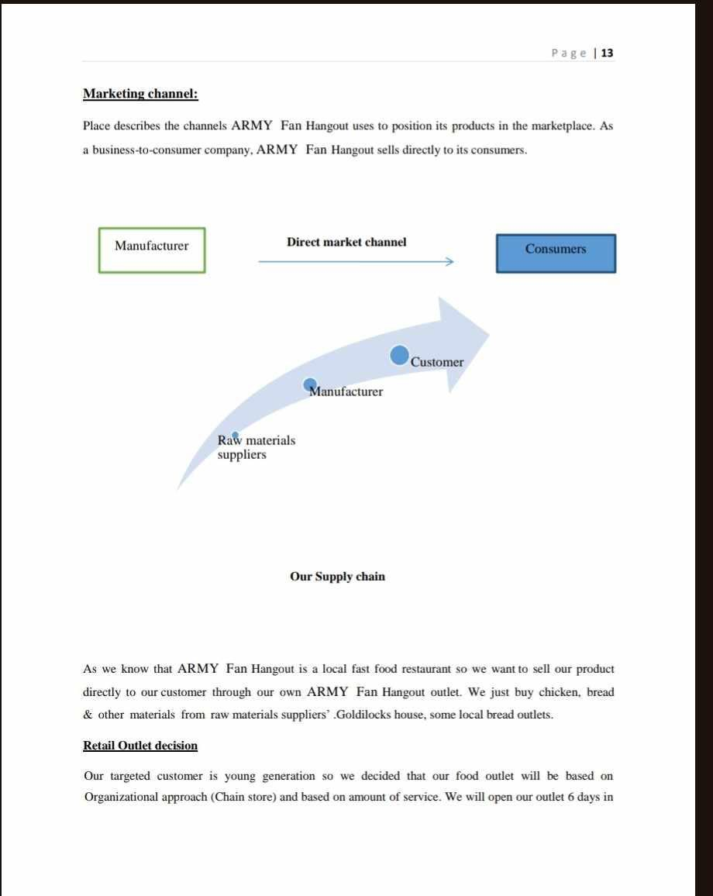
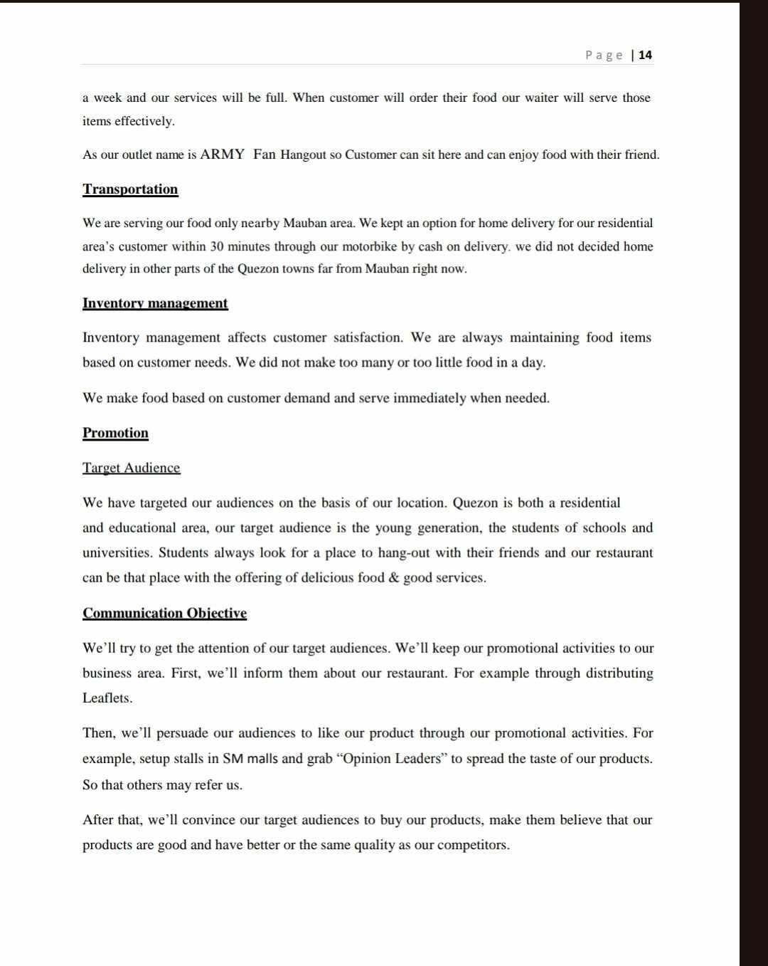
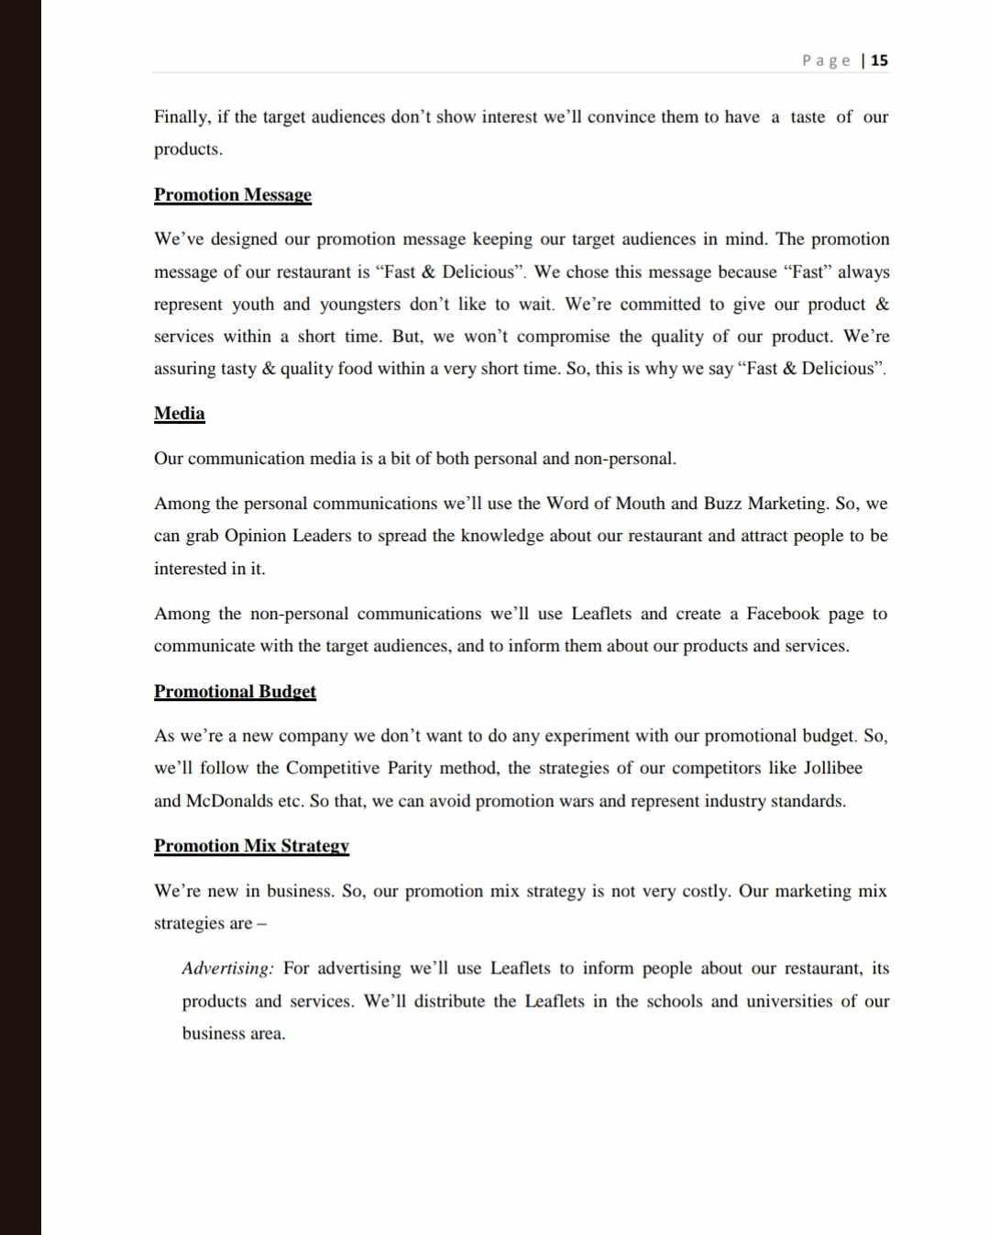
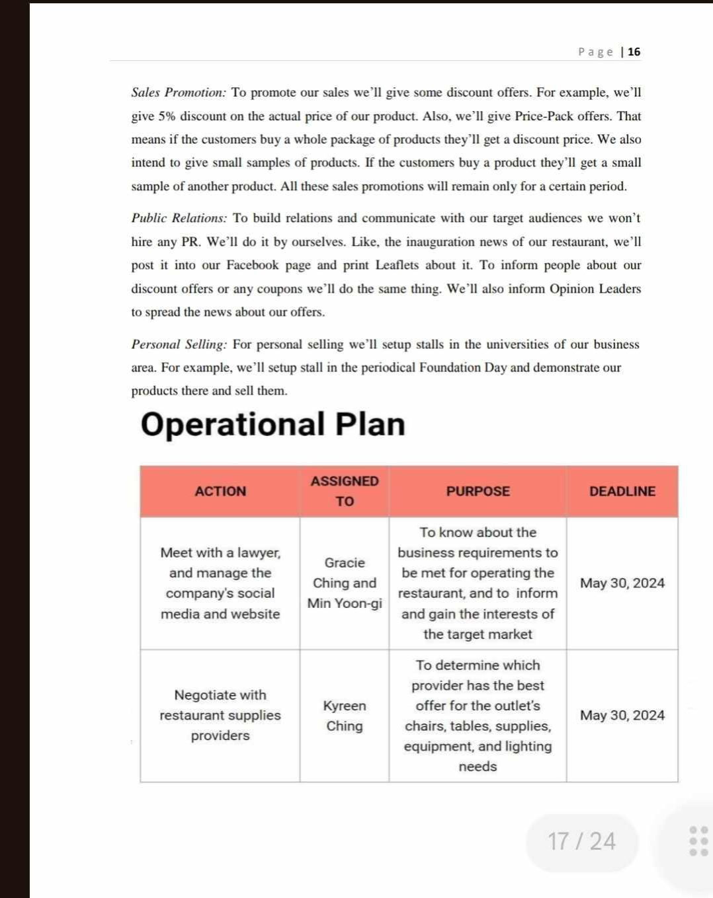
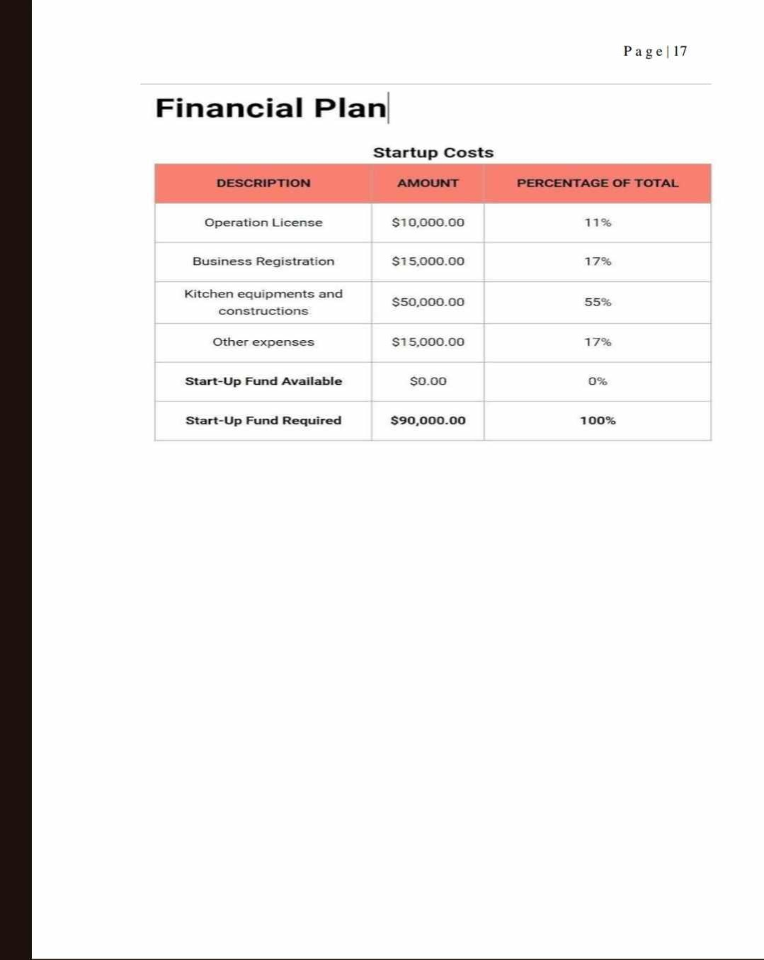
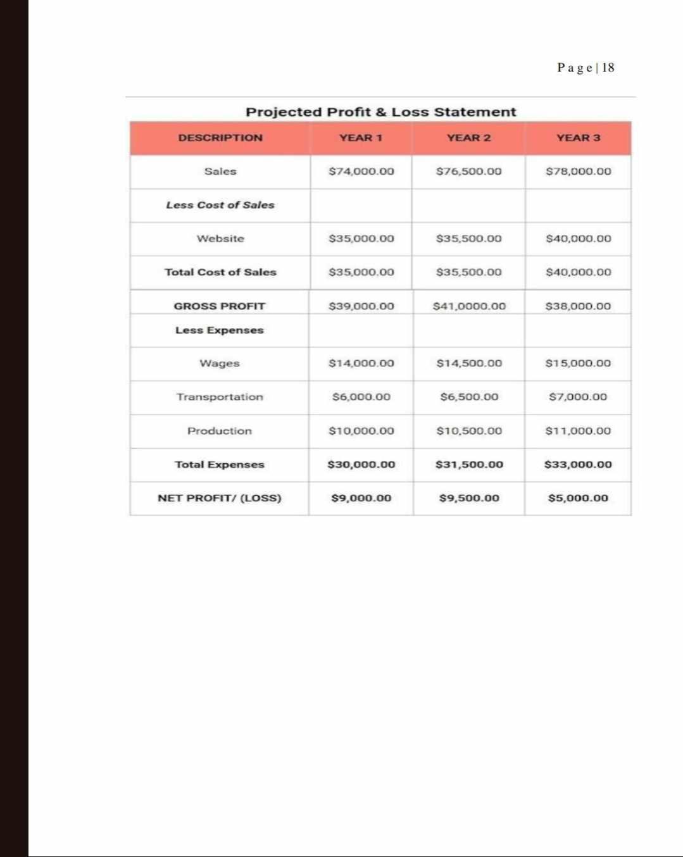
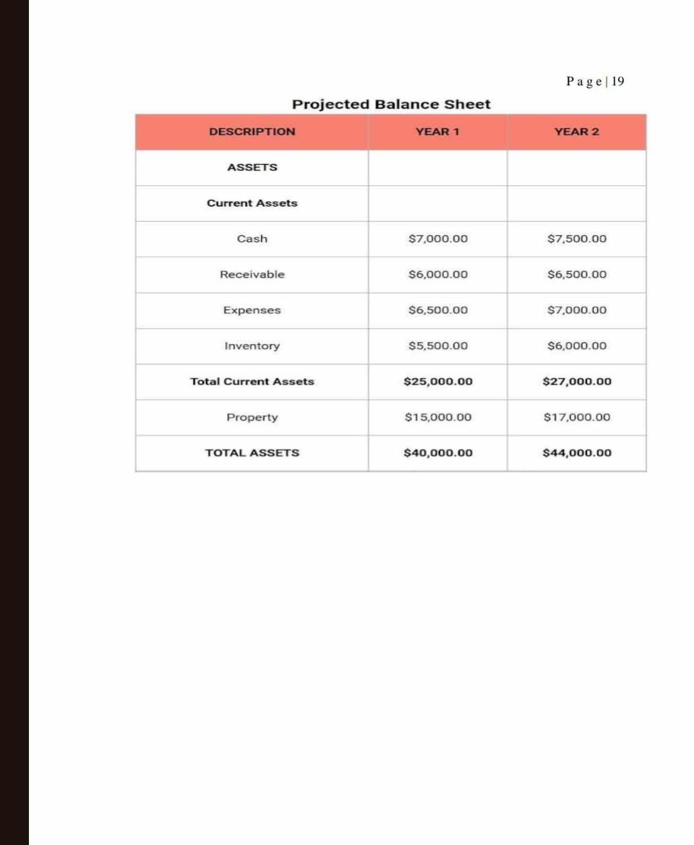
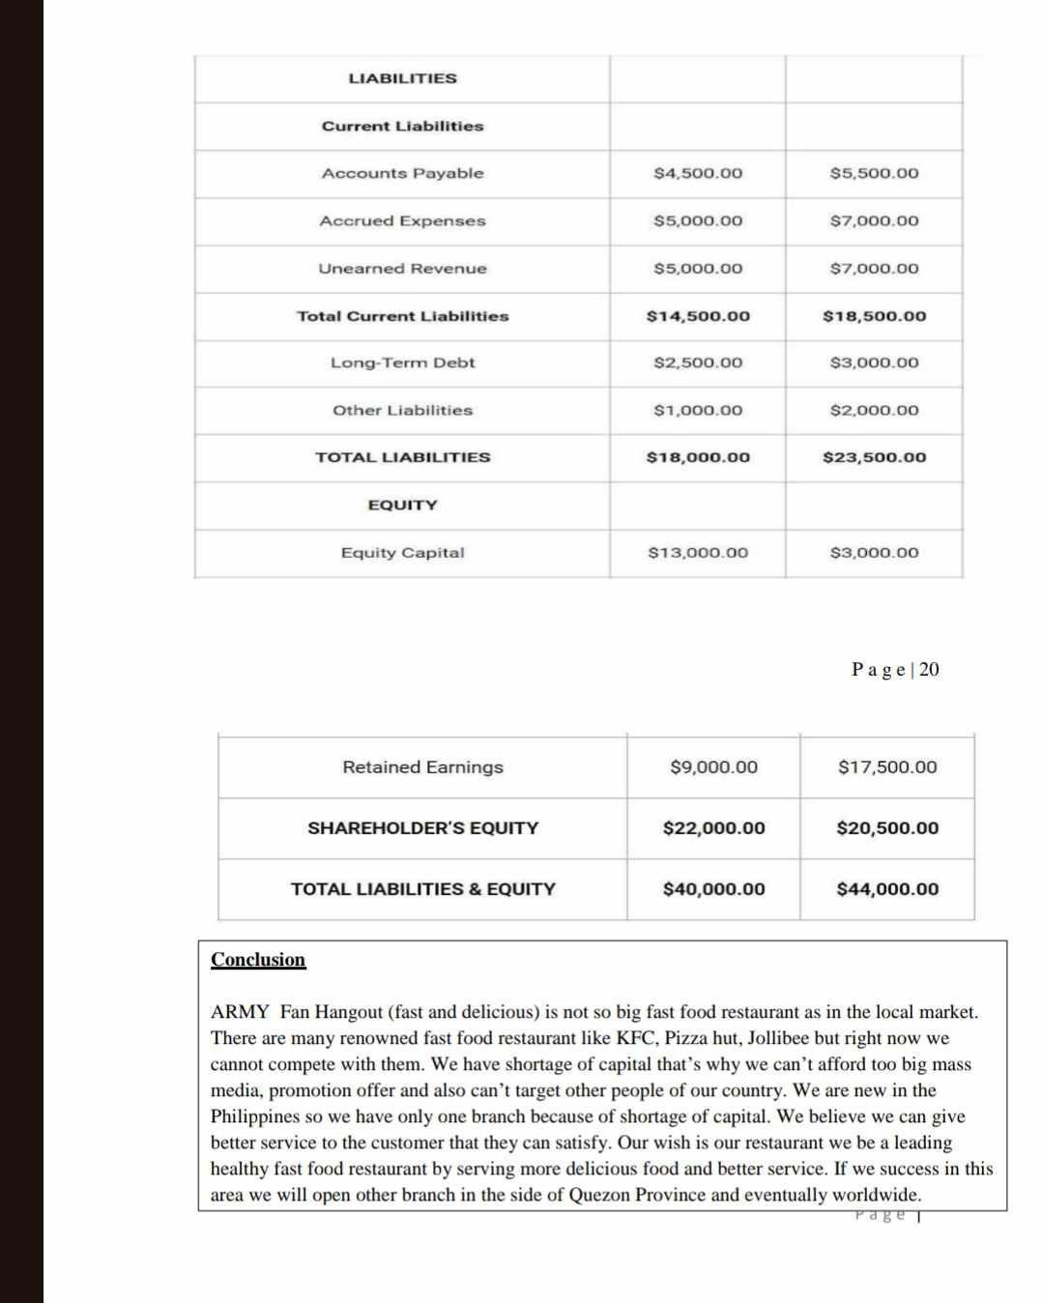
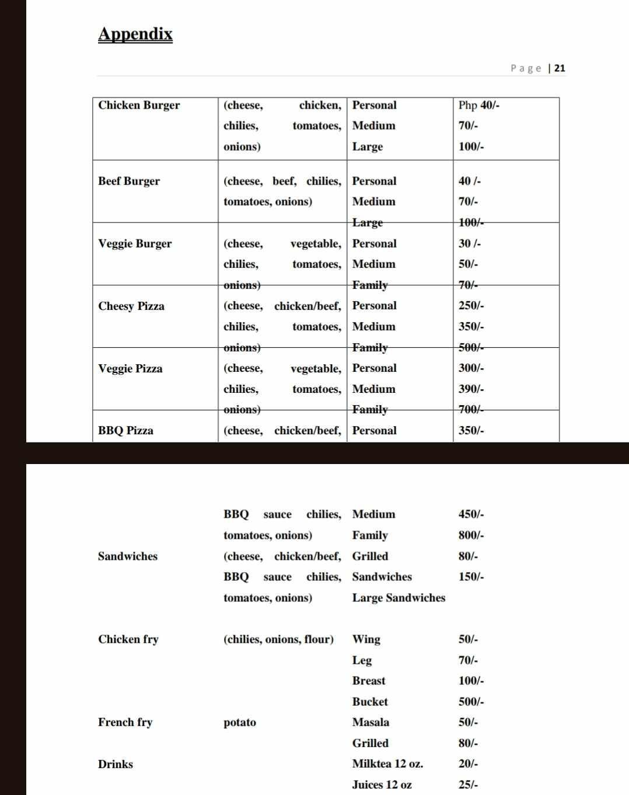

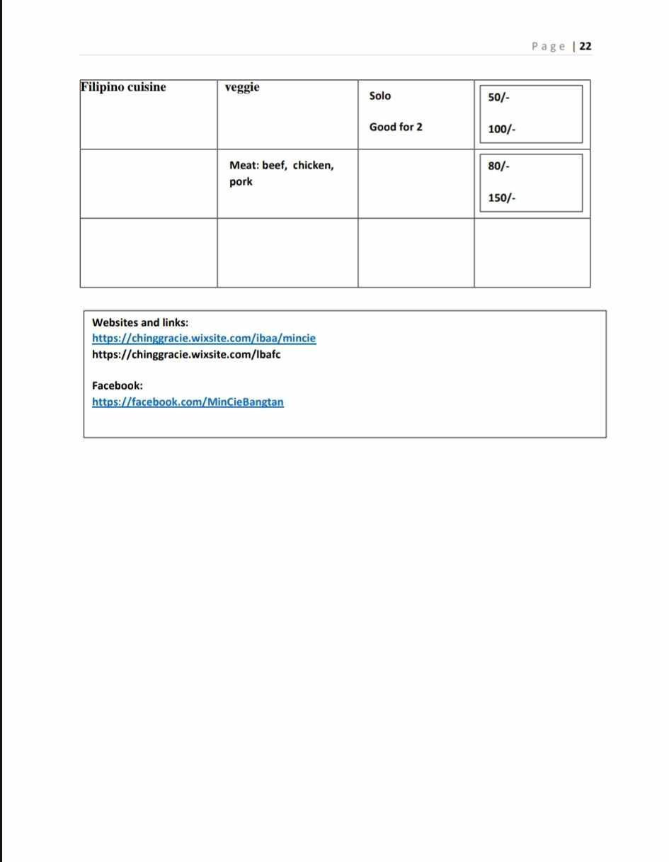
NOTE: All proposed prices are in Philippine peso currency

You can modify this proposed business plan suitable in your location.

This will serve as your guide in the format of the BTS-ARMY Fan Café business as a franchisee.

THANK YOU FOR YOUR SUBSCRIPTION AS OUR FRANCHISEE PARTNER


The Proposed Building for the BTS-ARMY Fan Cafe

